IT RCSA Audit Documentation
Server Protection – BSI.IT.10.C19
Design Assessment, Walkthrough and Sample of One (BigFix action 00-126993 – CrowdStrike Windows sensor)
DESIGN RATING | SAMPLE | OBSERVATIONS
SATISFACTORY | BigFix 00-126993  PASS | 2

Control | BSI.IT.10.C19 – Server Protection (Key, Semi-Automated, In every operation)
Review period | 07/05/2025 – 07/04/2026 (evidence captured 11/03/2026)
Walkthrough | IT RCSA (Edward Morfa) met with Ian Rojo (control owner) and [Infrastructure / InfoSec participants – to be confirmed] on [walkthrough date - to be confirmed]
Sample of one | BigFix permanent action 00-126993 SOFTWARE_DEPLOYMENT_CROWDSTRIKE_WINDOWS_SENSOR – issued 11/19/2024, Open, 25 of 25 applicable computers completed
Evidence folder | CDA/C19_CDA_Evidence and CPA/C19_CPA_Evidence. Start with BSI.IT.10.C19_E00_Evidence Index.xlsx.

Control description
[BSI.IT.10.C19 Server Protection] In every operation and upon imaging of a server, Infrastructure Engineering installs Endpoint Protection on the server to mitigate the risk of any malicious software. Exceptions to disable malware protections on server are approved by the CISO (or delegate).

How to use this document
All files sit in this control's CDA and CPA folders, named by E-number (for example C11_CPA_Evidence / E02). The E00 Evidence Index lists every file with its MD5. Each result in Section 3 names its evidence and where to look. Section 4 lists every place the sample appears. Results read: Pass (green), Fail (red), Observation / Open (amber - not an exception).

Evidence References
Ref | Evidence | Used for
CDA E01 | Virus and Malware Protection Standard v6.0 (07/28/2026) | SUS.VMPS.4.2.3.2, 4.2.3.3, 4.2.3.5 (p.8); sec. 6; Appendix E
CDA E02 | Virus and Malware Protection Standard v5.2 (05/28/2025) | In force at start of period
CDA E03 | Linux CrowdStrike install procedure | Manual install steps
CPA E01 | BigFix CrowdStrike permanent action 11/03/2026 | Action 00-126993 (sample of one)
CPA E02 | CMDB extract 11/04/2026 | 5 CIs, all created 04/2025
CPA E03 | SEF exceptions 07/01/2025 – 07/04/2026 | Blank file

1. Design Effectiveness Summary
The control design is effective. Trigger: server build. Windows servers carry the CrowdStrike Falcon sensor in the image, and BigFix permanent action 00-126993 pushes the sensor to any domain machine where it is missing – it never expires, re-applies an unlimited number of times and retries up to 5 times (CPA E01). Linux servers get the sensor at build, installed by the Linux admin with InfoSec's settings (CDA E03). Criteria: EDR must run continuously on all servers and exceptions need CISO approval through SEF (CDA E01, SUS.VMPS.4.2.3.2–4.2.3.3, sec. 6).
Overall Rating: Satisfactory, with observations: (1) the Linux install note is not under document control (no owner, date or version); (2) the SEF export for the period is blank and needs confirmation.

2. WT Summary
IT RCSA met with Ian Rojo (control owner) and [Infrastructure / InfoSec participants – to be confirmed] on [walkthrough date - to be confirmed]. The owner confirmed the process is unchanged from the 06/06/2025 walkthrough.
- Windows: sensor in the gold image. BigFix action 00-126993 has member actions 00-126994 Servers (Miami Group), 00-126995 Servers (Virginia Group) and 00-126996 Workstations & Laptops. A machine without the sensor becomes relevant and gets it installed.
- Linux: InfoSec provides the CID and settings; the Linux admin installs the RPM, sets the CID, starts the sensor and confirms it in the console or with ps -e | grep falcon-sensor.
- Monitoring: InfoSec watches the CrowdStrike console; gaps go to Infrastructure through ServiceNow.
- Exceptions: an agent that can't be installed or must be disabled needs a SEF exception approved by the CISO (or delegate).
Sample of one: BigFix action 00-126993 was checked end to end. Results are in Section 3.
Based on the walkthrough, the control appears to be designed appropriately. The BigFix action was live for the whole period, covers both server groups and shows every applicable computer completed.

3. Sample of One – BigFix action 00-126993
Workpaper column | Value / conclusion | Evidence reference | Result
"installs Endpoint Protection on the server" – install method (A1) | BigFix baseline SOFTWARE_DEPLOYMENT_CROWDSTRIKE_WINDOWS_SENSOR (Master Action Site) | CPA E01, Source section | Pass
Covers servers (A1) | Member actions 00-126994 Servers (Miami Group), 00-126995 Servers (Virginia Group) | CPA E01, Member Actions box | Pass
Active for the whole period (A1) | Issued 11/19/2024 12:24:59 PM by MIAYPER; State Open on 11/03/2026 | CPA E01, Details / Actions list | Pass
"In every operation" – re-applies to new / missing (A2) | Never expires; re-applied as a policy an unlimited number of times; retried up to 5 times | CPA E01, Execution box | Pass
Execution result | 100.00% Completed – 25 of 25 applicable computers; 26 reported | CPA E01, Status box | Pass
In-period deployments | 07/02/2025 single action 1/1; 09/02/2025 SERVERS (MIAMI Group) 3/3 – both completed | CPA E01, Actions list | Pass
Exceptions approved by CISO | None needed; SEF export blank | CPA E03 | Pass
Linux servers built in the period | CMDB extract has 5 CIs, all created 04/2025 – no in-period Linux sample | CPA E02 | Open
Conclusion: Sample BigFix action 00-126993 PASSED. The action was open for the whole period, covers both server groups, never expires and completed on all 25 applicable computers, in line with SUS.VMPS.4.2.3.3. The Linux side is an open item until the in-period population is received.

4. Evidence Locator – where to find the sample
Ref | Evidence | What it shows
CDA E01 | Virus and Malware Protection Standard v6.0 – SUS.VMPS.4.2.3.2–4.2.3.5 (p.8), sec. 6 | Criteria
CPA E01 | BigFix CrowdStrike permanent action 11-03-2026 – Figure 1 | Status, members, behavior, details (Exhibit A1)
CPA E02 | CMDB extract 11-04-2026 – Page 1 rows 2–6 | 5 CIs created 04/2025
CPA E03 | SEF export | Blank
WP2 | WP2 BSI.IT.10.C19 Server Protection 2026.xlsm – CPA tab row 53 and row 63 | Same results in workpaper form

Appendix A – Sample Evidence
Exhibit A1: BigFix console – action 00-126993 (CPA E01)
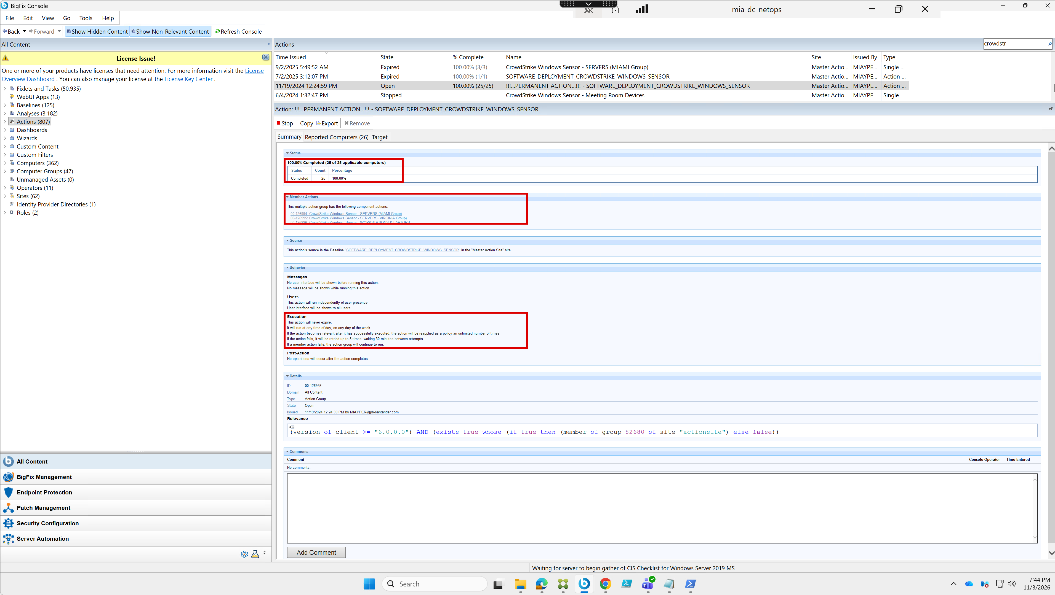
Source: CPA E01 – BigFix console on mia-dc-netops, captured 11/03/2026 7:44 PM by Roman Francisco. Red boxes: status (25 of 25), member actions, execution behavior.
Field | Value
Action | 00-126993 !!!...PERMANENT ACTION...!!! – SOFTWARE_DEPLOYMENT_CROWDSTRIKE_WINDOWS_SENSOR
Issued | 11/19/2024 12:24:59 PM by MIAYPER
State | Open
Status | 100.00% Completed (25 of 25 applicable computers); 26 reported
Members | 00-126994 Servers (Miami Group); 00-126995 Servers (Virginia Group); 00-126996 Workstations & Laptops
Behavior | Never expires; re-applied unlimited times when relevant; retried up to 5 times, 30 minutes apart
Other actions in list | 09/02/2025 CrowdStrike Windows Sensor – SERVERS (MIAMI Group) 3/3 Expired; 07/02/2025 SOFTWARE_DEPLOYMENT_CROWDSTRIKE_WINDOWS_SENSOR 1/1 Expired
Package: CDA and CPA evidence folders, E00 index, WP2 2026 workbook and this document.

